Губенко Дмитро ПД-22

Практична робота 2

1. CREATE DATABASE basa_pr2;

USE basa_pr2;

CREATE TABLE table_pr2 (

id INT AUTO_INCREMENT PRIMARY KEY,

name VARCHAR(50),

age INT

);

ALTER TABLE table_pr2

ADD COLUMN email VARCHAR(100);

INSERT INTO table_pr2 (name, age, email) VALUES ('John Doe', 30, 'john.doe@example.com');

INSERT INTO table_pr2 (name, age, email) VALUES ('Jane Smith', 25, 'jane.smith@example.com');

SELECT * FROM table_pr2;

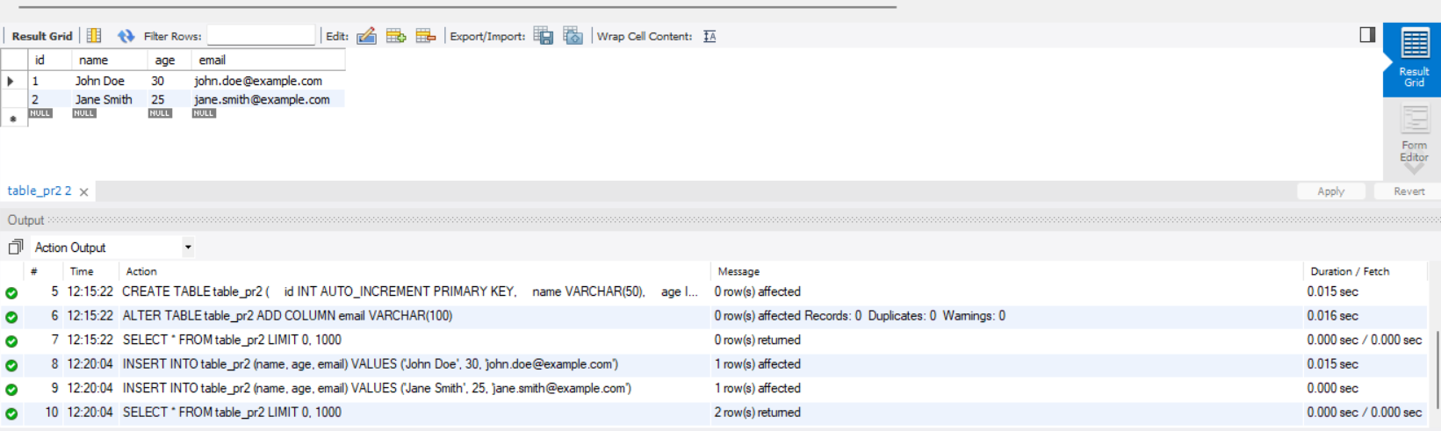

2. SELECT * FROM table_pr2;

SELECT * FROM table_pr2 WHERE age > 25;

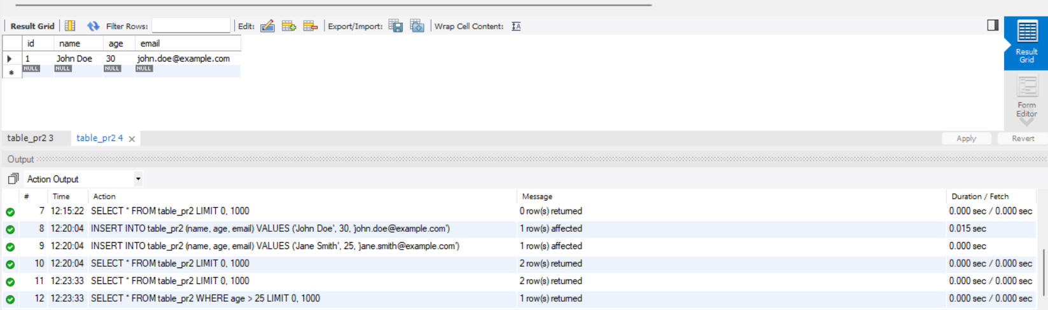

3. DELIMITER //

CREATE PROCEDURE GetEvenIdRecords()

BEGIN

SELECT * FROM table_pr2 WHERE id % 2 = 0;

END //

DELIMITER ;

-- Виклик процедури

CALL GetEvenIdRecords();

